**Experimenting with** [**https://andersbrownworth.com/**](https://andersbrownworth.com/)

1. SHA256 Hash: Secure Hash Algorithm

Link: <https://andersbrownworth.com/blockchain/hash>

This is a demo for encrypting the text into non-convertible hash, this hash and information is unconvertible. Even a single space can change the Hash value.

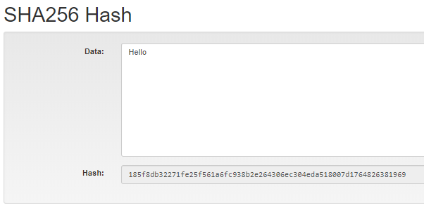

After adding a space after hello we have entirely different hash.

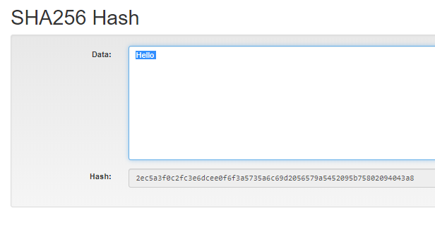

1. Block:

Link: <https://andersbrownworth.com/blockchain/block>

This will demonstrate what all things a block contains in blockchain network.

Block number, Nounce or Mining Key, Data, Hash.

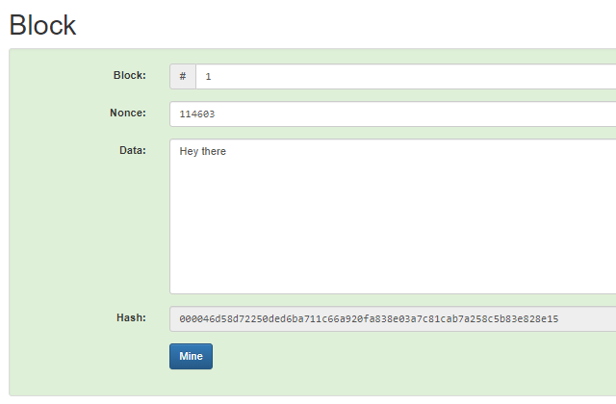

1. Blockchain:

Link: <https://andersbrownworth.com/blockchain/blockchain>

A demonstration of single node’s blockchain.

Each block in the chain contains Block number, Nounce, Data, Previous Hash, Current Hash.

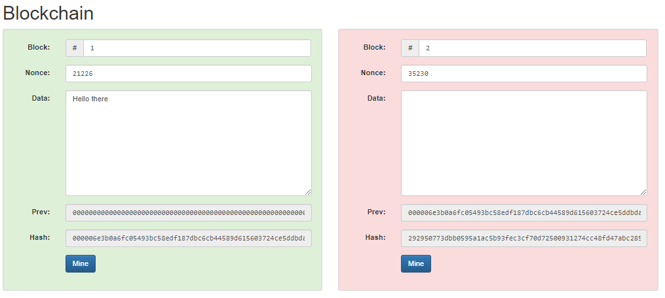

After we add data, we have to find the mining key so that first 4 digit of Hash gets ZERO.

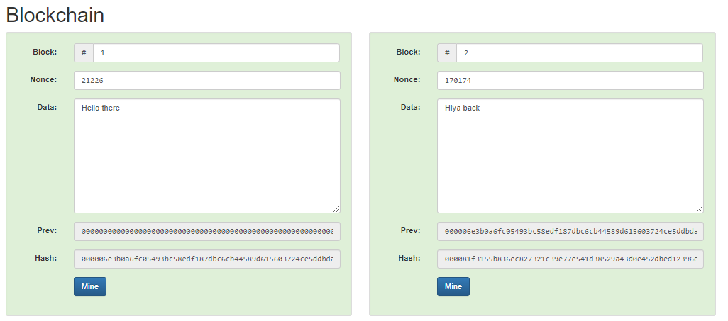

1. Distributed Blockchain:

This is the perfect example of public block chain.

